**CHAPTER FOUR**

**SYSTEM IMPLEMENTATION**

**4.0 Introduction**

This chapter highlighted the technical tools use for the project, system testing, system requirement and evaluation.

**4.1 Technical Tools Used**

The system will be developed using software development tools and are classified into Front –End tools, Back – End tools and Web Server.

**4.1.1 Front–End Development Tools**

The frontend here means the web pages that user will be navigating through. HTML, CSS & Bootstrap are the technologies selected for the development of the frontend.

1. **HTML:** HTML stands for Hyper Text Markup Language, it is the standard markup language for creating Web pages. HTML elements tell the browser how to display the content and it also describes the structure of a Web page.
2. **CSS:** CSS stands for Cascading Style Sheets, it describes how HTML elements are to be displayed on screen, paper, or in other media. CSS saves a lot of work. It can control the layout of multiple web pages all at once.
3. **Bootstrap:** Bootstrap is a free front-end framework for faster and easier web development. It includes HTML and CSS based design templates for typography, forms, buttons, tables, navigation, modals, image carousels and many other, as well as optional JavaScript plugins. Bootstrap also gives you the ability to easily create responsive designs.

**4.1.2 Back-End Development Tools**

The backend is the part of the software that handles websites logic and databases. PHP & MYSQL is the technologies selected for the development of the backend

1. **PHP:** PHP stands for Hypertext Preprocessor, is a server scripting language and a powerful tool for making dynamic and interactive web pages. The scripts are executed on the server.
2. **MYSQL:** SQL stands for Structured Query Language, is a standard language for accessing and manipulating databases. It lets you access and manipulate databases.

**4.1.3 The Web Server**

A web server is a software and hardware that uses HTTP (Hypertext Transfer Protocol) and other protocols to respond to client requests made over the World Wide Web. Apache web server is selected, it is the best choice for its security, reliability and availability.

**4.1.4 Other Tools**

1. **Visual Studio Code**: Visual Studio Code is a popular code editor that provides a rich set of features for JavaScript development. It offers excellent support for PHP development, including debugging, IntelliSense, and integrated terminal features
2. **Git and GitHub:** Git is a version control system that allows for efficient collaboration and tracking of code changes. GitHub is a popular web-based hosting service that supports Git repositories and facilitates team collaboration.

**4.3 SYSTEM TESTING**

The system is tested using the Black Box testing, in which the system developed is tested in order to evaluate the system’s compliance with the specified user requirements.

**Table 4.1 Admin requirement testing**

This table outlines the specific requirements tested for the admin module of the system. It details the criteria used to evaluate the functionality, performance, and security of the admin features, ensuring they meet the intended specifications and user needs.

|  |  |  |  |  |  |
| --- | --- | --- | --- | --- | --- |
| TEST ID | FUNCTION | DESCRIPTION | EXPECTED RESULT | ACTUAL RESULT | STATUS |
| 1 | Add New event | Admin try to add new event to the system | New event added to the system | New event were added into the system | Successful |
| 2 | Edit event | Admin try to edit a event in the system | event edited in the system | event was edited in the system | Successful |
| 3 | Delete event | Admin try to deleted event in the system | event deleted in the system | event was deleted in the system | Successful |
| 4 | Add venue | Admin try to add venue to the system | New venue added to the system | New venue was added into the system | Successful |
| 5 | Edit venue | Admin try to edit a venue in the system | venue edited in the system | venue was edited in the system | Successful |
| 6 | Delete venue | Admin try to deleted a venue in the system | venue deleted in the system | venue was deleted in the system | Successful |
| 7 | Manage audience list | Admin try to manage audience list the system | Audience list manage in the system | audience list was manage in the system | Successful |
| 8 | Manage booking list | Admin try to manage booking list the system | Booking list manage in the system | Booking list was manage in the system | Successful |
| 9 | Login | Admin try to login into the system | Admin login into the system | Admin was login into the system | Successful |
| 10 | Logout | Admin try to logout in the system | Admin logout in the system | Admin was logout in the system | Successful |

**Table 4.2 User requirement testing**

This table outlines the specific requirements tested for the user module of the system. It details the criteria used to evaluate the functionality, performance, and security of the admin features, ensuring they meet the intended specifications and user needs.

|  |  |  |  |  |  |
| --- | --- | --- | --- | --- | --- |
| TEST ID | FUNCTION | DESCRIPTION | EXPECTED RESULT | ACTUAL RESULT | STATUS |
| 1 | View upcoming event | User try to view upcoming event in the system | User view a upcoming event in the system | Upcoming event was view in the system | Successful |
| 2 | Register for event | User try to register for event in the system | User register for event into the system | user was registered into the system | Successful |
| 3 | Book event venue | User try to for event venue in the system | User book for event venue in the system | Event venue was booked in the system | Successful |

Home page of the system displaying the upcoming events

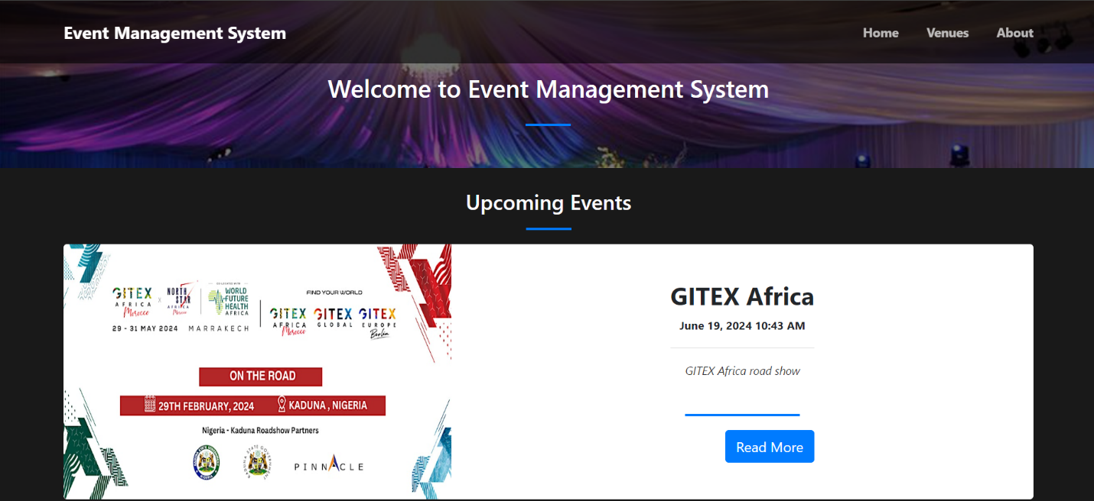

Dashboard of the system that display all the event venues

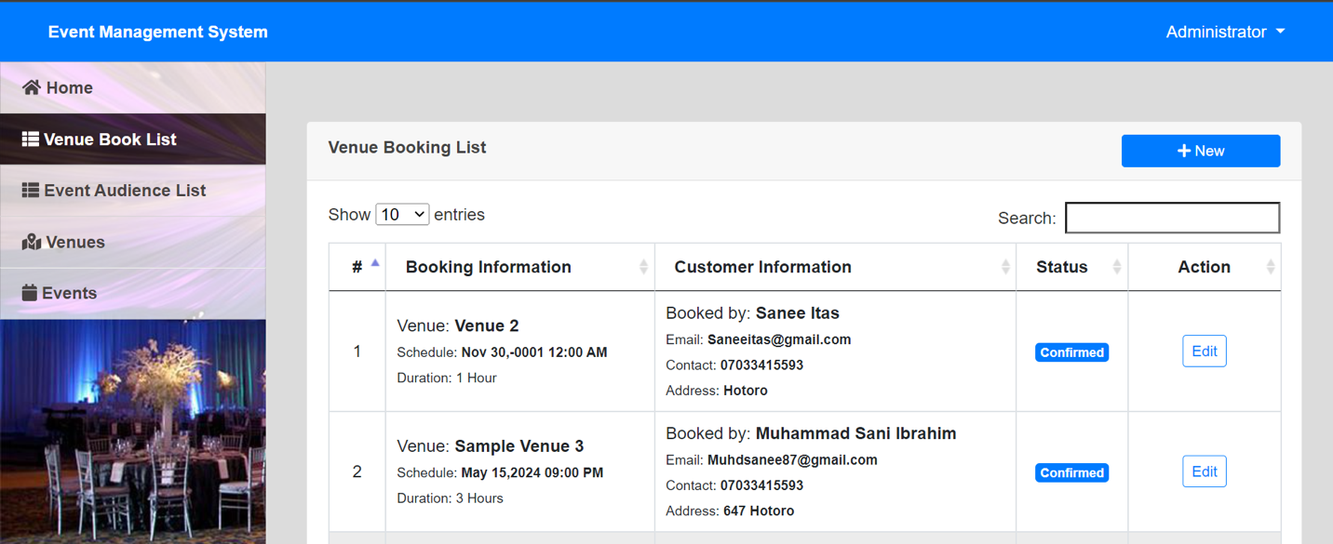

**4.3 SYSTEM REQUIREMENT**

**Software Requirement**

* 1. Operating System: Android, Windows, Mac, Linux etc.
  2. Browsers: Opera Mini, Chrome, Firefox etc.

**Hardware Requirement**

1. Processor: Minimum 1 GHz; Recommended 2GHz or more.
2. Ethernet connection (LAN) or a wireless adapter (Wi-Fi)
3. Memory (RAM): Minimum 1GB; Recommended 4GB or above.

**4.4 SYSTEM EVALUATION**

System evaluation includes measuring the final system against its initial performance goals as well as performing ongoing testing to see that the system continues to meet those goals.

The method used to gather feedback from software stakeholder is through holding regular meetings with them. The feedbacks include:

1. The user interface color should be change to another color, so as to be user friendly.
2. The platform should include other sections for other events.

**4.6 CHAPTER SUMMARY**

The main focus of this chapter was the implementation of the software, the frontend and backend technologies and tools used in developing the software, the software and hardware requirements needed for the software to be used and also how the functionality of the system was tested and evaluated to meet its requirement.